**Take Remote of client system**

1. Type IP address of client system.

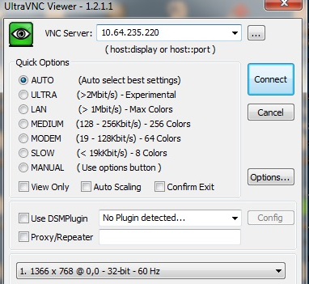

1. Enter password which set on application.

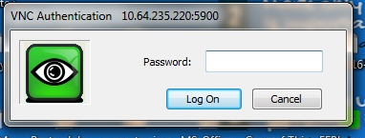

1. User will get below screen, ask user to click on Accept.

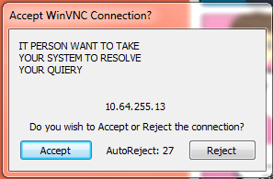

1. You will get remote of user system.

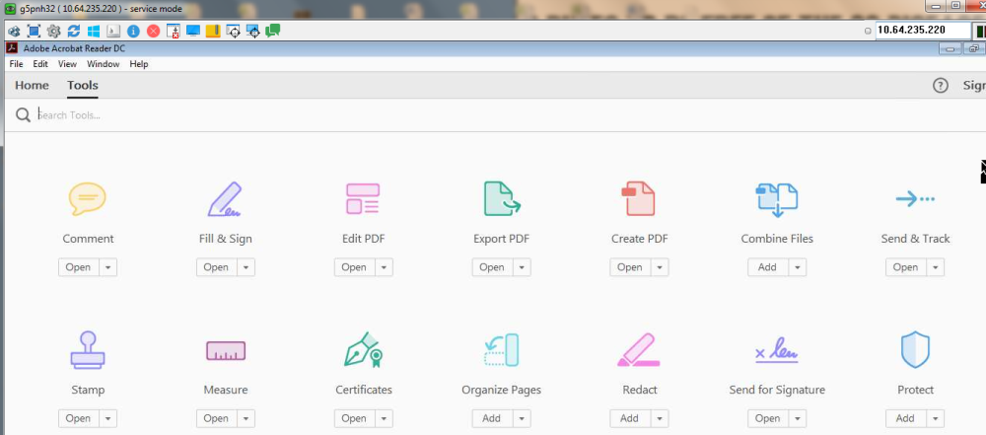

**Thank You**